Will Kelsey, Nick Krysko

Assignment 4 Use Case Model

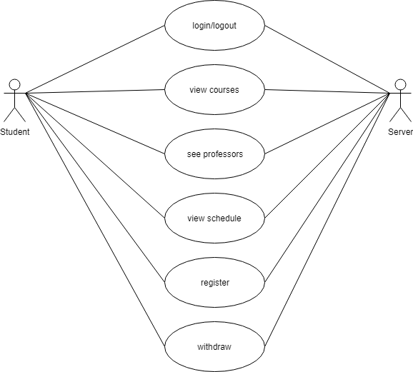 The Student in CURSE has a few abilities. The largest being registration. Each student can view courses available and register for those they need. As in real life, the student cannot be in two places at once and must not have time overlaps for registration. Students who cannot register for courses and wish to not be enrolled for the current semester can withdraw.

Alternatively